Website Planning Document

Forecast For You

Author: Carly Kjelstrom

Site Purpose

The purpose of this site is three-fold. The home page will contain a current weather story with corresponding image and town information. The town weather pages will contain weather conditions and other town information or relevant articles/content. All pages will have images that are used to reflect the current weather condition data on the town pages and the towns themselves.

Target Audience

The target audience will be adults who live in or around the cities, or tourists looking to visit the cities. The age range will likely be between 28 and 45. The will be expecting a professional and clean website with clear information.

Site Map

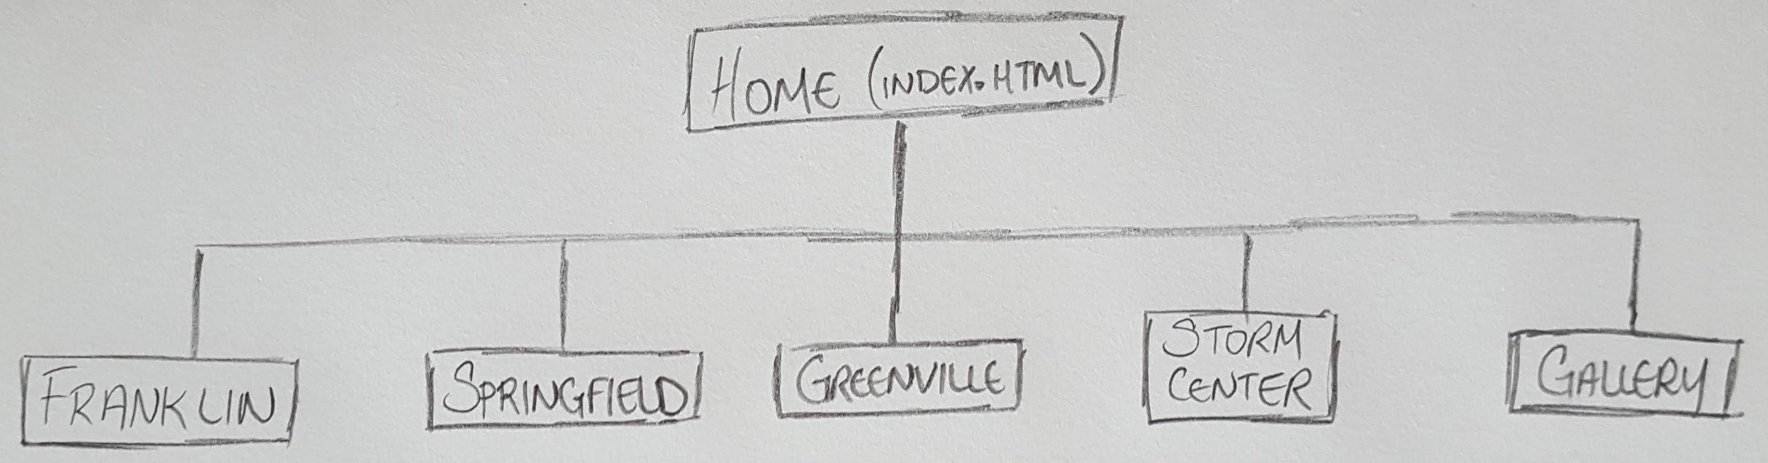

Color Scheme

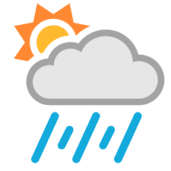

Typography

Headings and Titles:

Akko Rounded Std regular

**Akko Rounded Std bold**

Information and Subtitles:

Stempel Garamond LT Std roman

**Stempel Garamond LT Std bold**

Wire-Frame Sketches

